FOR IMMEDIATE RELEASE
Sony Contacts:
Cheryl Goodman, Larry Smalheiser, Corporate Communications
selpr@sony.com
858.942.4079

Caroline Mizuki, Imaging Products & Solutions Americas
caroline.mizuki@sony.com
858.951.6271

Sony Electronics’ “Visual Story™” App Features New Updates to Empower Event Photographers

Updated Visual Story App Version 1.1 Now Includes Live Galleries and Remote Viewing Capabilities with Expanded Support and Camera Compatibility

SAN DIEGO, CA – March 30, 2021 – Sony Electronics Inc. today announced new updates to “Visual Story” – a mobile application for professional event photographers that simplifies the process of delivering photos to their clients immediately after an event through automatic gallery creation, AI (artificial intelligence) image selection and web delivery. The new application version 1.1 for “Visual Story” offers expanded support and a new “Live gallery” feature that makes remote viewing and participation more accessible.
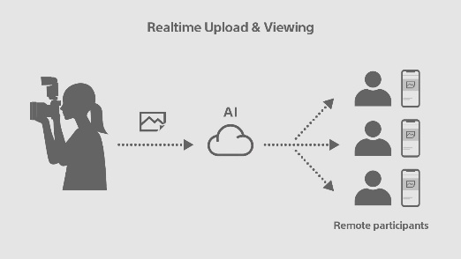
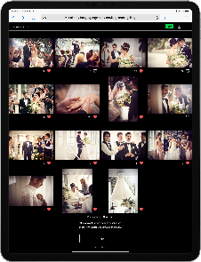
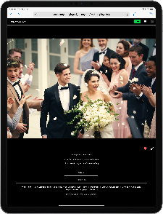

New Live Gallery Feature for Socially Distanced Live Events
Visual Story Version 1.1’s new Live Gallery feature allows professional event photographers to meet the growing demand for remote participation during the actual event. This enables the photographer’s clients to share photo galleries with their friends, family and colleagues, to then view photos of their event, such as a wedding, corporate, school or sporting event, in real time to create a more immersive experience.

Live Gallery helps simplify a professional workflow by allowing Auto transfer while shooting with a compatible Sony Alpha brand camera, automated image selection using AI, and applying edit presets to all images within a live gallery at the same time. Live Gallery viewers can also like specific photos, which the photographer can use to choose final image selections to deliver to their client.

Upgraded Selection Options
The newly updated Visual Story app also now includes an object detection filter to easily locate images focusing on specific items such as a cake, food, tableware and jewelry. The photographer can also choose images that are only included in a live gallery or those with likes.

Compatibility and Availability
Visual Story Version 1.1 is available now for iOS in the App Store for free and is compatible with select Sony cameras including: Alpha 7C, Alpha 7R IV, Alpha 7S III, Alpha 9, Alpha 9 II as well as Alpha 7 III (updated to firmware Version 4.0 or later), Alpha 1 and FX3^{i}.

Sony’s new Visual Story is available to download for free HERE, and development on additional platforms is under discussion.

Learn more about Visual Story HERE

A product video on the new Live gallery feature can be viewed HERE

Exclusive stories and exciting new content shot with Sony's imaging products can be found at www.alphauniverse.com, a site created to educate and inspire all fans and customers of Sony α - Alpha.

###

About Sony Electronics Inc.
Sony Electronics is a subsidiary of Sony Corporation of America and an affiliate of Sony Corporation (Japan), one of the most comprehensive entertainment companies in the world, with a portfolio that encompasses electronics, music, motion pictures, mobile, gaming, robotics and financial services. Headquartered in San Diego, California, Sony Electronics is a leader in electronics for the consumer and professional markets. Operations include research and development, engineering, sales, marketing, distribution and customer service. Sony Electronics creates products that innovate and inspire generations, such as the award-winning Alpha Interchangeable Lens Cameras and revolutionary high-resolution audio products. Sony is also a leading manufacturer of end-to-end solutions from 4K professional broadcast and A/V equipment to industry leading 4K and 8K Ultra HD TVs. Visit http://www.sony.com/news for more information.

Notes:

Membership to “Visual Story” account and app on smartphone required with connection to Wi-Fi. See “Visual Story” terms and conditions/privacy policy for details. Download app at the App Store. Network services, content, and operating system and software subject to terms and conditions and may be changed, interrupted or discontinued at any time and may require fees, registration and credit card information.
Please refer to the website for a full list of compatible models. Firmware must be updated on cameras to ensure compatibility.

